

**Year 12 Human Biology**

**Test: Human Evolution**

|  |
| --- |
| Name: |
| Teacher: |

|  |  |  |
| --- | --- | --- |
|  | Marks Received | Marks Available |
| Multiple Choice |  | 20 |
| Short Answer |  | 20 |
| Extended Answer |  | 10 |
| Total |  | 55 |

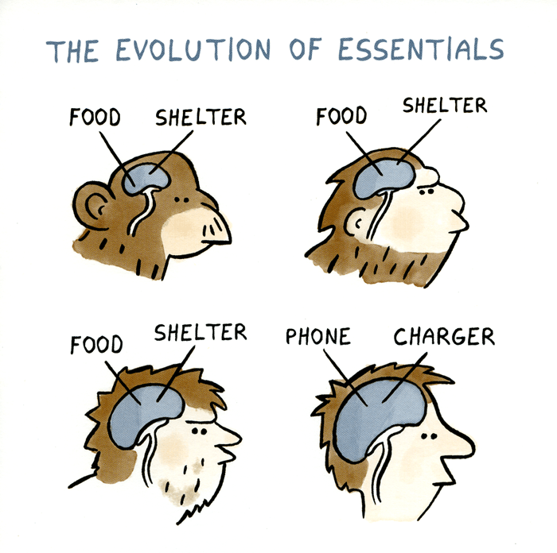Weighting: 5%

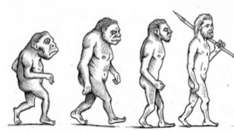





**SECTION A – MULTIPLE CHOICE**

1. Which one of the following is **not** a likely part of human evolution from the early hominins?
   1. Increase in brain size
   2. Shift in the position of the foramen magnum
   3. Development of binocular vision
   4. Reduction in size of canine teeth

The next three questions are based on the following data:

Studies of four skeletons from different excavation in the same general region of Africa yielded the following data:

|  |  |  |  |
| --- | --- | --- | --- |
| **Skeleton Number** | **Cranial Capacity (cc)** | **Relative length of arms and legs** | **Artefacts found with skeletons** |
| 1. | 400 | Arms longer than legs | Arrow |
| 2. | 1300 | Arms shorter than legs | None |
| 3. | 600 | Arms the same length as legs | None |
| 4. | 1000 | Arms shorter than legs | Stone Axe |

1. The skeleton most like that of modern humans is:
   1. 1
   2. 2
   3. 3
   4. 4
2. The individuals which probably walked most erect are:
   1. 1 & 2
   2. 1 & 3
   3. 1 & 4
   4. 2 & 4
3. The presence of an arrow near skeleton 1 is best interpreted by saying the individual:
   1. Was killed by an arrow
   2. Used fire for cooking
   3. Could make arrowheads
   4. Lived at a time when tools were used
4. One of the last marked physical characteristics to evolve in *Homo sapiens*  has been the:
   1. Chin
   2. Upright posture
   3. Arched foot
   4. Broad pelvis
5. Which one of the following characteristics would **not** be used to decide whether a primate should be classified as a hominin rather than an ape?
   1. Number of incisor teeth
   2. Arches formed by the bones of the foot and bipedalism
   3. Shape of the dental arcade and body hair
   4. Relative size of canine teeth and erect posture
6. The fossil primate skull was found in a cave near Johannesburg, South Africa. Some details of the discovery are set out below:
7. Estimated age of rock in which skull was found approximately 2 million years
8. Description of skull – brain capacity about 600cc rounded cranium. No bony crest for attachment of neck muscles. Position of hole for entry of spinal cord suggests that animal walked upright. Jaw rounded rather than U-shaped. Canine teeth small and relatively inconspicuous.
9. Tool embedded in rock of the same age were found a short distance from the skull.

This evidence suggests that the fossil could be the remains of:

* 1. Neanderthals
  2. *Homo erectus*
  3. *Australopithecus*
  4. *Homo habilis*

1. In a dig in an East African cave an anthropologist found and ancient fire-place that contained the fire-blackened fossil bones of an extinct species of antelope. Nearby at the same level some stone tools were found that had been shaped on two faces to form an axe handle. The occupier of the cave was most likely:
   1. *Australopithecus afarensis*
   2. *Homo habilis*
   3. *Homo neanderthalensis*
   4. *Homo erectus*

|  |  |  |
| --- | --- | --- |
| **Hominin** | **Cranial Capacity** | **Forehead** |
| 1 | 850cc | Slight |
| 2 | 1450cc | Often receding |
| 3 | 1050cc | Slight |
| 4 | 1400cc | Rounded |

The data presented above indicate that:

1. Hominin 1 is *Homo sapien* and hominin 2 is *Homo erectus*
2. Hominin 1 is *Homo habilis* and hominin 3 is *Homo sapien*
3. Hominin 3 is *Homo erectus* and hominin 4 is early Homo
4. Hominin 2 is *Homo neanderthalensis* and hominin 3 is *Homo erectus*
5. If a hominid skull had an obvious sagittal crest it would suggest that the hominin:
6. was very large in stature.
7. was probably a meat eater.
8. probably ate tough vegetation.
9. was more likely to use tools.
10. The table below shows the number of nucleotide differences between a section of mitochondrial DNA is modern humans, chimpanzees and a Neanderthal fossil.

|  |  |  |  |  |
| --- | --- | --- | --- | --- |
|  | **Neanderthal** | **Chimpanzee 2** | **Chimpanzee 1** | **Human 2** |
| **Human 1** | 21 | 76 | 77 | 14 |
| **Human 2** | 27 | 79 | 80 | - |
| **Chimpanzee 1** | 72 | 22 | - | - |
| **Chimpanzee 2** | 70 | - | - | - |
| **Neanderthal** | - | - | - | - |

Based on this data in the table, which individual is related most closely to the Neanderthal?

1. Human 1
2. Human 2
3. Chimpanzee 1
4. Chimpanzee 2

**Question 12 refers to the table below:**

|  |  |  |
| --- | --- | --- |
|  | **Presence of Diastema** | **Amount of wear on opposing (occlusal) surfaces of molar teeth** |
| **A** | Some individuals | Extreme |
| **B** | No individuals | Moderate to extreme |
| **C** | All individuals | Very little |

1. Dental features can be used to distinguish various hominins. Which of the following correctly identifies A, B and C?
   1. A – Chimpanzee, B – *Auatralopithecus,* C – Modern Human
   2. A – *Auatralopithecus,* B – Chimpanzee,C – Modern Human
   3. A – *Auatralopithecus,* B – Modern Human,C – Chimpanzee
   4. A – Modern Human*,* B – Chimpanzee,C –*Auatralopithecus*

**The next question refers to the diagram below that depicts primate skulls.**



1. Which of the following would be the most likely evolutionary sequence towards *Homo sapiens*?
   1. 3, 4, 2, 1
   2. 3, 2, 4, 1
   3. 4, 3, 2, 1
   4. 4, 2, 3, 1

**The NEXT question refers to the image of a fossilised skull:**

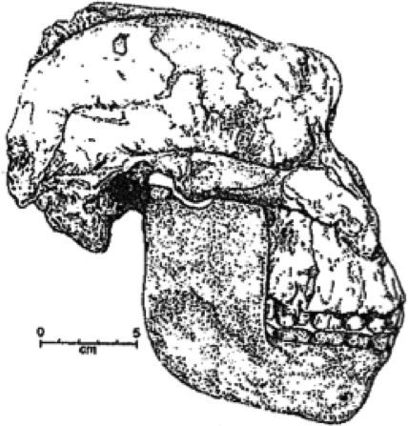

1. Which of the following features seen in this specimen are hominin evolutionary trends?
   * + 1. relatively large cerebral cortex
       2. increased prognathism
       3. enlarged molars and premolars
       4. sagittal crest
2. Which of the following correctly matches the hominin to the associated lifestyle change?
3. *Homo habilis* – food sharing, *Homo neanderthalensis* – cave murals
4. *Homo erectus* – use of fire, *Homo sapiens* – first to perform ritualised burials
5. *Homo neanderthalensis* – development of agriculture, Australopithecines – home bases
6. *Homo habilis* – food sharing, *Homo erectus* – cooperative hunting
7. Artefacts differ from fossils in that artefacts
8. are found associated with human remains.
9. are made of organic material that can be carbon dated.
10. are objects produced by hominins for a particular purpose.
11. are works of art with religious significance.
12. The group of primates that includes apes and humans is known as the:
13. anthropoids
14. homomids
15. hominins
16. great apes
17. the first hominin species known to have made tools was Homo
18. *neanderthal*
19. *afarensis*
20. *erectus*
21. *habilis*
22. Which of the following is the correct order of cultural development associated whith the hominin ancestors of modern humans?
23. Oldowan, Acheulian, Mousterian
24. Oldowan, Mousterian, Acheulian
25. Acheulian, Mousterian, Oldowan
26. Acheulian, Oldowan, Mousterian
27. The diagram below illustrates one interpretation of the evolution of humans. The dottedlines indicate possible evolutionary relationships, and the vertical bars sjhow the period from which fossils are known for each species.



This diagram suggests that

1. *Homo habilis* is an ancestor of modern humans.
2. *Homo sapiens* us descended from *Paranthropus robustus*
3. *Homo erectus* became extinct before modern humans appeared.
4. *Australopithecus* species may have given rise to modern humans.

**SECTION B – SHORT ANSWER**

1. The diagram below shows three lower jaw / mandible outlines.



* 1. Which of the three jaws is that of an apes; A, B or C?  *C* (1 mark)
  2. Give three reasons for your answer. (2 marks)

*Large canines and Diastema*

*Square shaped dental arcade (Must say dental arcade not jaw)*

1. Apes with hands adapted to knuckle walking would not be able to use tools as members of the genus Homo can. Describe the adaptations of the hands of the Homo genus to enable them to handle tools as effectively as they can. (4 marks)

* *Straight fingersLonger thumb / finger ratio*
* *More mobile / agile thumb*
* *Power grip – to grasp objects/ wrap fingers around/ thumb over fingers*
* *Precision grip – touch fingers to thumb/ pincer grip*



1. Using the diagrams above, describe 3 differences of the human foot compared to the ape foot and explain the significance of each difference to bipedalism. (6 marks)

|  |  |  |
| --- | --- | --- |
| *Human* | *Ape* | *Significance* |
| * Calcaneus bone larger forms bigger heel | * Smaller heel | * First point of contact / stability on stepping * Allows for start of rolling step * Balance |
| * Parallel / aligned * Large toe not opposable | * Toes not aligned * Opposable big toe | * Push off on stepping * Rigid foot for weight bearing / balance |
| * Both longitudinal and transverse arch | * Only longitudinal arch | * Balance * Allow rolling step / heel – foot – big toe |



1. 

The pictures above represent a particular tool culture.

a) Name this tool culture. Explain your choice. (2 marks)

*Oldowan*

*It is a riverstone which has had one side chipped to form a blade.*

b) Which Homo species is responsible for their production. (1 mark)

*Homo habilis*

c) Name **one** other tool culture and describe how the materials used affects the manufacturing technique. (2 marks)

* *Achulian – tools made from rocks*
* *Method – percussion to shapr rocks on both sides – bifacial*
* *Mousterian – tools made from flint*
* *Levallois method - large chips were flaked off and shaped*
* *Upper Paleolithic – other materials like bone, ivory and antler were used*
* *Various methods with multiple steps*

1. How has the use of tools contributed to the trend of increasing cognitive abilty of the *Homo* genus?

(2 marks)

* *Tool use leads to more complex thought/ reasoning/problem solving*
* *Communication during tool manufacture and hunting*
* *Frontal lobe growth*

**SECTION C – EXTENDED ANSWER**

1. *a) Homo erectus* and *Paranthropus robustus* were alive during relatively the same time around 1.5 million years ago. Palaeontologists excavated a skeleton and artefacts from the above time period and were able to classify its species. Describe 4 different indications that could be used to determine which species the remains belong to. (4 marks)

|  |  |  |
| --- | --- | --- |
| Feature | Parnthropus | Homo |
| Sagittal crest | present | Absent |
| jaw/ zygomatic arch/ cheekbones/teeth | Large | Small |
| Cranial capacity | 550 – 600cc | 1000cc |
| Arm / leg ratio | Longer arms than legs | Longer legs than arms |
| Hearth/ burnt rocks / | none | present |
| Tools | none | Acheulian tools |

b) For **three (3)** of the indications you have mentioned above, explain **one** inference that palaeontologists could be made about the lifestyle of the hominin. (6 marks)

Skeleton

* *Pr* has large teeth, jaw, cheekbones, sagittal crest / smaller cranium/brain
* Indicating strong musculature, and a tough fibrous vegetarian diet
* *He* has smaller teeth, jaw, no sagittal crest,
* indicating a meat / softer diet
* *He* large cranium/brain
* Indicating meat / protein diet
* Broccas and wernickes areas indicate speech ?
* *He* had longer legs than arms
* Striding gait, walking, running for hunting???

Artefacts

* *He* had hearths indicating fire was used
* cook food / warmth / community
* Acheulian tools for hunting / cutting meat / chopping bones /
* meat diet/ cooperation with hunting